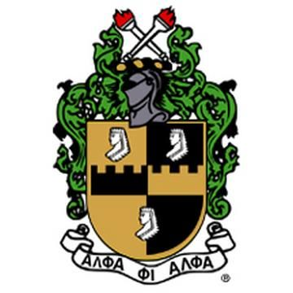
Alpha Phi Alpha Fraternity, Inc.

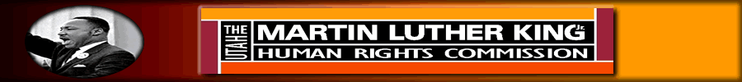

Dr. Martin Luther King Jr.
Oratorical Contest
Registration Form

The State of Utah Martin Luther King, Jr. Commission, the men of Alpha Phi Alpha Fraternity, Inc. and the University of Utah Martin Luther King, Jr. Youth Leadership Award Committee would like to announce our 1st collaborative MLK, Jr. Oratorical Contest. The purpose of the MLK Oratorical Contest is to identify problems or special topics of interest within society and determine how the problem or topic relates to the goals, objectives, and teachings of Dr. Martin Luther King, Jr.

The contest will provide students with the opportunity to express their thoughts and showcase communication skills through oration. The contest fosters the development of leadership qualities as well as the ability to think intelligently. It also prepares the student for the acceptance of duties and responsibilities of entering the real world. Solid public speaking and written communication skills will be an integral part of an individual's chosen career field.

All interested contestants should complete the attached registration packet and return it no later than December 7th. The competition will be held on December 18, 2010 at the Salt Lake County Mayor’s Office located at 2100 State Street from 10:00 am to 1:00 pm.

We look forward to receiving your completed packet and hearing the great talent Utah has to offer. All completed packets and questions for the oratorical contest should be sent electronically to Dr. Roderic R. Land at roderic.land@yahoo.com.

Sincerely,

Dr. Roderic R. Land, Chair
State of Utah MLK Commission

Jasen Lee
Program Chair
Alpha Phi Alpha Fraternity, Inc.

Dr. Jennifer Williams Molock
Assistant Vice President
University of Utah
Office for Student Equity and Diversity

Student Information
Name: ________________________________________________________ Grade: ____ Age:_____
School: ___________________________________________________________________________
Email address: _____________________________________________________________________
Home address: _____________________________________________________________________
City: ____________________________________Zip: ______________Telephone # _____________

Speech Title:__________________________________________________________________

Date of Presentation: ___________________

Contestant Certification Signature
In compliance with the current Dr. Martin Luther King, Jr. Oratorical Competition rules, I certify with my signature that I, alone, prepared my speech and that it is substantially original. Further, I understand that protests regarding originality will be limited to judges and contestants, and that any protest must be lodged with the Chief Judge prior to the certification of the winner and alternate by the Chief Judge.

_____________________________________ ____________________
Contestant’s Signature Date

Chief Judge Certification Signature
In compliance with the current Belford V. Lawson Oratorical Competition rules, I certify with my signature that I received SPEAKER’S CERTIFICATION OF SPEECH ORIGINALITY prior to the beginning of the competition.

_____________________________________ ____________________
Chief Judge’s Signature Date

*Note: This form is to be completed by each contestant and must be submitted prior to the contest to the Chief Judge.

